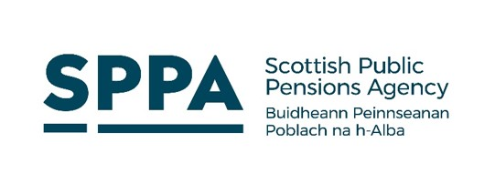
2015 Remedy
Member Update

Revised Delivery Timetable
Issued 27/2/2025

This is an important update for members of the Teachers’ Pension Scheme including active (in work) and retired members.

Delivery Position

The Scottish Public Pensions Agency (SPPA) has this week set out a revised delivery timetable for the 2015 Remedy. This means that not all members will be provided with a remedy choice by the end of March 2025.

The work to deliver Remedy is hugely complex and all public service scheme managers across the UK are facing similar challenges, with most having already revised their delivery timescales accordingly.

Our annual workload has increased fivefold as we work to deliver remedy and ensure we continue to pay pensions to retired public sector workers.

It is disappointing to have to revise our timeframe but it is important that this is realistic and achievable.

Why has this changed?

We have been continually clarifying complex regulations which has required repeated engagement with government bodies and resulted in us having to change specifications multiple times.

We have also been introducing innovative new approaches not seen in many other parts of the public sector in Scotland such as automation, which will make the process faster and more efficient in the longer term.

Building an automated solution has taken us longer in the pre-delivery phase with final requirements meaning multiple development phases of the solution, but will pay dividends once we move into delivery. Not every case is suitable for automation, and some will still need to be manually administered. These cases will take longer to complete and we have taken this into account in our revised delivery timeline.

However, once we start producing RSS through the automated process, we will have a much better idea of how many we will have to process manually. This may impact on our delivery projections meaning we can deliver more quickly or give more accurate estimates of final delivery dates as we go through the process.

What does this mean for you?

To provide clarity and certainty, the SPPA website has been updated with information about the new timescales and you can find information relating to your scheme and circumstances by visiting the Remedy Hub: https://pensions.gov.scot/teachers#TeachersRemedyHub

Staying informed

We will be issuing newsletters for all retired and active members in March to provide the latest information.

If you are retired, you can also sign up to receive our monthly updates which will be issued directly to you by email: https://pensions.gov.scot/teachers/teachers-remedy-hub/teachers-remedy-im-retired see section, ‘When we’ll contact you’.

